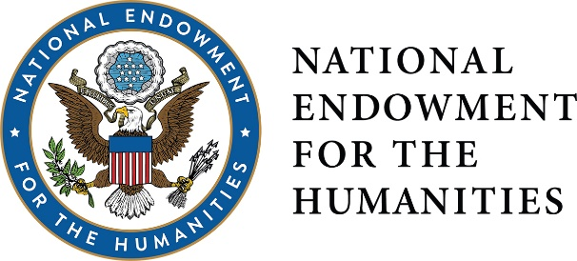
DIVISION OF PUBLIC PROGRAMS
POSITIONS IN THE PUBLIC HUMANITIES
To help Exhibitions, Historic Places, and Humanities Discussions applicants fund the professional staff they need to undertake large humanities projects, and to provide new graduates experience in public humanities work, NEH is offering a new funding opportunity, Positions in Public Humanities, as part of its existing Public Humanities Projects (PHP) Implementation Grant. Any organizations applying for a PHP grant for Exhibitions, Historic Places, or Humanities Discussions at the implementation level may request additional funding of up to $100,000 for one of these positions to work on the proposed grant project. The deadlines are offered every year
in January and August.

The extra funds would provide salary of $50,000/year for a one- or two-year, full-time, entry-level position at the applicant’s institution (the institution must provide benefits equal to those offered other staff members—this cost is not included in the grant funds). The position must be filled by a recent graduate (within five years) from a public humanities MA or PhD program whose area of expertise is essential for successful completion of the project.

In addition to working on the NEH grant project, the person should also administer three different types of public programs during the two-year tenure. For example, the person might organize film and panel discussions, family gallery talks, or an oral history day program.

Examples of Positions in Public Humanities:

As part of a new emphasis on interpreting slavery throughout its entire historic site, a Southern plantation might create a position for a recent anthropology PhD to conduct outreach and collect oral histories from descendants of slaves. This research and personal testimony would inform the writing of a final interpretive plan for the site.

An art museum reinstalling its American wing might hire a recent graduate from a public humanities program who would work with curators and educators to devise a high school curriculum interpreting the American collection.

As part of a statewide celebration of women’s history, a state humanities council might recruit a recent digital humanities PhD to devise a GPS-based app of significant women’s history sites throughout the state.

Positions in Public Humanities funds may not be used to:
- pay salaries of current staff members;
- pay project consultants;
- hire anyone who would have teaching or administrative duties during the two-year period; or
hire anyone still enrolled in a degree-granting program.

Applicants may request support for only one such position per the January or August grant cycles.

CONTACT
Have an idea for a project? Wondering if you’re eligible to apply? Want some clarification on the application process? Talk to us: publicpgms@neh.gov or call 202.606.8269.
For more information and full guidelines, visit us online:
http://www.neh.gov/divisions/public.

Follow us on Twitter @NEH_PubPrograms.

