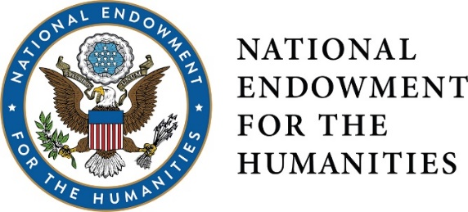

DIVISION OF PUBLIC PROGRAMS
PUBLIC HUMANITIES PROJECTS
PLANNING AND IMPLEMENTATION GRANTS
RESEARCH. COLLABORATE. CONNECT. INSPIRE.

WHO WE ARE
The Division of Public Programs supports a wide range of programs that promote active exploration and engagement for broad audiences in history, literature, archaeology, art history, philosophy, and other fields of the humanities. Deadlines are in August and January.
WHAT WE FUND: EXHIBITIONS · HISTORIC PLACES · HUMANITIES DISCUSSIONS
The Public Humanities Projects grant program supports projects that provide public audiences with analytical investigations of significant topics on history and culture. The PHP program has 3 categories: Exhibitions (permanent exhibitions on display for at least 3 years, travelling exhibitions displayed at a minimum of two venues in the U.S., or single-site, temporary exhibitions, funded at lower grant amounts), Historic Places (historic house, district, or site interpretive programs such as tours, living history programs, or exhibits), and Humanities Discussions (a sustained series of discussions and special public programming built around humanities resources and a focused theme, lasting 3 months-2 years).
INVESTIGATE…
Have an idea for a humanities project? Assembled a team of scholars? Developing an Exhibition or Historic Places project? PLANNING grants (up to $75,000, or $40,000 for temporary, single-site exhibitions), designed to fund the exploratory stages of an exhibit or public program, are a good option. Activities must include scholarly consultation and collaboration, research, and refinement of humanities themes. (Planning level grants are not available for Special Projects discussion programs).

…THEN CREATE AND ENGAGE.
Research complete? Project plans and ideas complete? Ready to start engaging audiences with your topic? Consider a PHP Exhibitions, Historic Places, or Special Projects IMPLEMENTATION grant (up to $400,000, or $100,000 for temporary, single-site exhibitions) to support final work on an exhibition, interpretive historic site project or public program series. Activities include final interpretation of humanities content, design and fabrication of exhibit and programming spaces, outreach, and evaluation.
COLLABORATE
In the Division of Public Programs, we like to say that we fund “content first, format second.” This means that each project needs to recruit a team of humanities advisers—content experts—to help inform the ideas and information in the project. These advisers work hand-in-hand with the project team throughout the process to ensure that the content being presented represents the best of what humanities scholarship has to offer.
PROCESS
Program officers from the Division of Public Programs will work with applicants to hone their proposal prior to submission. Every application submitted to the Public Humanities Projects program is peer-reviewed and all applicants receive feedback.
CONTACT
Have an idea for a project? Wondering if you’re eligible to apply? Want some clarification on the application process? Talk to us: publicpgms@neh.gov or call 202.606.8269.
For more information and full guidelines, visit us online:
http://www.neh.gov/divisions/public.

Follow us on Twitter @NEH_PubPrograms.

