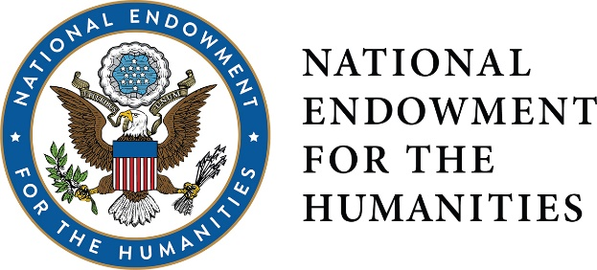
DIVISION OF PUBLIC PROGRAMS
DIGITAL PROJECTS FOR THE PUBLIC
DISCOVER. DESIGN. CREATE.

WHO WE ARE
The Division of Public Programs supports a wide range of programs that promote active exploration and engagement for broad public audiences in history, literature, archaeology, art history, comparative religion, philosophy, and other humanities fields.
PURPOSE + PLATFORMS
The Digital Projects for the Public grant program welcomes applications for digital projects that explore significant topics or ideas in the humanities, offer creative approaches to humanities content, and encourage dialogue, discussion and experiential modes of learning. Formats we support include:
- Games
- Websites
- Mobile applications
- Curated online experiences
- Site-specific/ augmented reality engagements
- Virtual reality environments
- Transmedia storytelling

(DPP does not support strictly promotional digital tools that do not add significant content.)
THINK ABOUT IT…
DISCOVERY grants (up to $30,000) are designed to fund the exploratory stages of a digital project. Activities must include: scholarly consultation, refinement of the humanities themes, digital media development, and analysis of potential platforms.

… PROTOTYPE IT…
PROTOTYPING grants (up to $100,000) support the creation of a proof-of-concept prototype. Other activities can include: further refinement of humanities content, consultation with scholars and digital media experts, scripting, user interface and backend development, audience evaluation and testing.
...THEN BUILD IT.
PRODUCTION grants (up to $300,000) support the final stages of a digital project, including: prototype refinement and beta testing, audience outreach, project distribution and public programming.
PEOPLE
In the Division of Public Programs, we like to say that we fund “content first, platform second.” This means that each project needs to recruit a team of humanities advisers—scholars—to help inform the ideas and information in the project. These advisers work hand-in-hand with the media team throughout the process to ensure that the project’s content represents the best of what humanities scholarship has to offer.
PROCESS
The deadline falls once a year during the second week of June. Program officers from the Division of Public Program will work with applicants to hone their proposal prior to submission (make sure you give us time!). After the review, every application submitted to DPP is eligible to receive further feedback from an NEH program officer and a panel of content and media experts. In other words, even if you’re not funded, your project can grow through the NEH.
CONTACT
Have an idea for a project? Wondering if you’re eligible to apply? Want some clarification on the application process? Talk to us: publicpgms@neh.gov or call 202.606.8269.
For more information and full guidelines, visit us online:
http://www.neh.gov/divisions/public.

Follow us on Twitter @NEH_PubPrograms.

