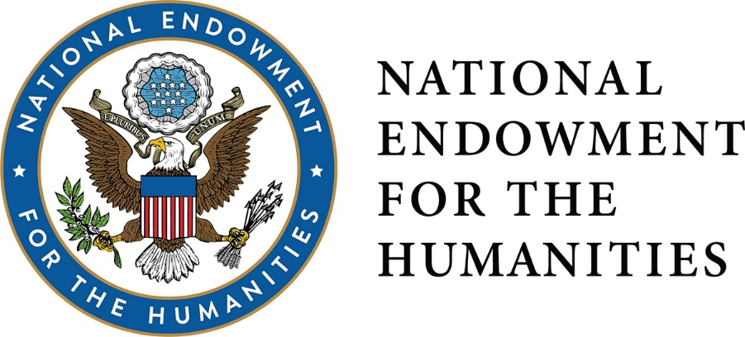
DIVISION OF PUBLIC PROGRAMS
EXPLORING THE HUMAN ENDEAVOR, ONE STORY AT A TIME.

WHO WE ARE
The Division of Public Programs supports a wide range of programs that promote active exploration and engagement for broad public audiences in history, literature, archaeology, art history, comparative religion, philosophy, and other fields of the humanities. Our funded projects offer fresh insights into often familiar subjects. While a Public Programs project might suggest an answer, it’s just as likely to raise important questions about its subject, encouraging conversation and debate. HUMANITIES INTEPRETATION IS REQUIRED, INNOVATION IS ENCOURAGED.

Curate. Discover. Engage. Interact

WHAT WE FUND
In the Division of Public Programs, we like to say that we fund “content first, platform second”. To that end, we offer four primary grant programs supporting humanities projects in multiple platforms and a range of public domains.

Public Humanities Projects (January and August deadlines) grants support museum exhibitions; tours and public programs at historic places; and humanities discussions focusing on Chairman’s “A More Perfect Union” initiative (https://www.neh.gov/news/more-perfect-union). Funding is offered at two stages in a project: planning and implementation. There are two deadlines each year, in early January and early August.
.
- Planning Grants (up to $75,000) support the development of humanities content, the project’s interpretive approach, and the exploration of potential formats.
- Implementation Grants (up to $ 400,000) support the final interpretation, design, and production of the project.
- Chairman’s Special Awards (up to $1,000,000) are implementation grants that support large-scale projects of national visibility and exceptional merit that promise to attract large audiences.

Media Projects (January and August deadlines) grant program supports film, television, and radio programs that explore significant events, figures, or subjects in the humanities. Three levels of support are offered:

- Development Grants (up to $75,000) fund the exploratory stages of a media project, including scholarly consultation and collaboration, refinement of the humanities themes, script development, and pre-production work.
- Production Grants (up to $650,000) support the end-stage work of a media project: the filming, recording, editing, and outreach activities that turn a great humanities idea into a publically engaging film, television, or radio project.
- Chairman’s Special Awards (up to $1,000,000), offered at the Production level only, support projects of exceptional merit that promise to reach large audiences and involve creative collaborations among diverse institutions.

Short Documentaries (January and August deadlines) grants support the production and distribution of documentary films up to 30 minutes that engage audiences with humanities ideas connected to the Chairman’s “A More Perfect Union” initiative (https://www.neh.gov/news/more-perfect-union). The Short Documentaries program supports production of single films or series of thematically-related short films.

- Production grants (up to $250,000) Short Documentaries makes awards of up to $60,000 for a single film. Applicants may also request funding to support a series of related short films at up to $60,000 per film, not to exceed a total request of $250,000.

Digital Projects for the Public (June deadline) welcomes applications projects that explore the humanities through digital and experiential platforms such as games, websites, mobile applications, curated online exhibition, AR, and VR. Two levels of funding are available:

- Discovery Grants (up to $30,000) support the exploratory stages of a digital project, including consultation, refinement of the humanities themes, analysis of potential platforms, and the creation of a design document.
- Prototyping Grants (up to $100,000) support the creation of a proof-of-concept prototype and other activities including: the further refinement of humanities content, consultation with scholars and digital media experts, scripting, user interface and backend development, and audience evaluation and testing.
- Production Grants (up to $300,000) support the final stages of a digital project, including: prototype refinement and beta testing, audience outreach, project distribution and public programming.

PROCESS
Program officers from the Division of Public Programs will work with applicants to hone their proposal prior to submission (make sure you give us time!). After review, every application submitted is eligible to receive further feedback from an NEH program officer and a panel of content experts and professionals in museums, media, or digital fields. In other words, even if you’re not funded, your project can grow through the NEH.

CONTACT
Have an idea for a project? Wondering if you’re eligible to apply? Want some clarification on the application process? Talk to us: publicpgms@neh.gov / 202.606.8269

Follow us on Twitter: @NEH_PubPrograms

